Code | Explanation
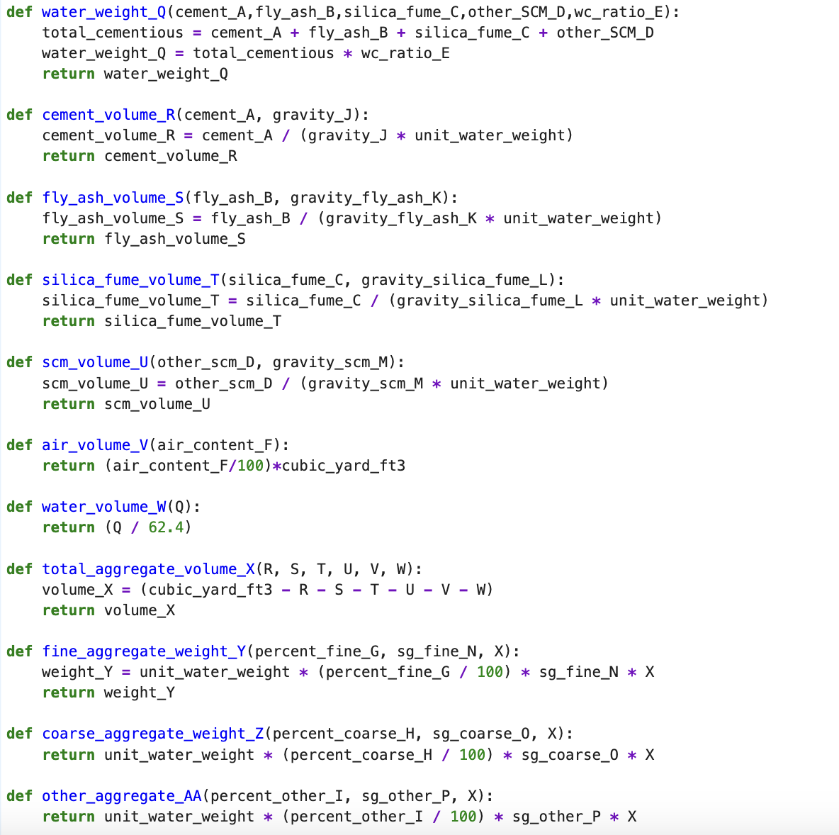 | What this code is doing is using the def function to do the calculations for each of the different volumes and weights needed in the excel document. It is doing this by passing in local variables that we will collect the value for by using the global variables we will get from the user later in the document. You want to put these def functions at the top since it is easiest for referring back to them
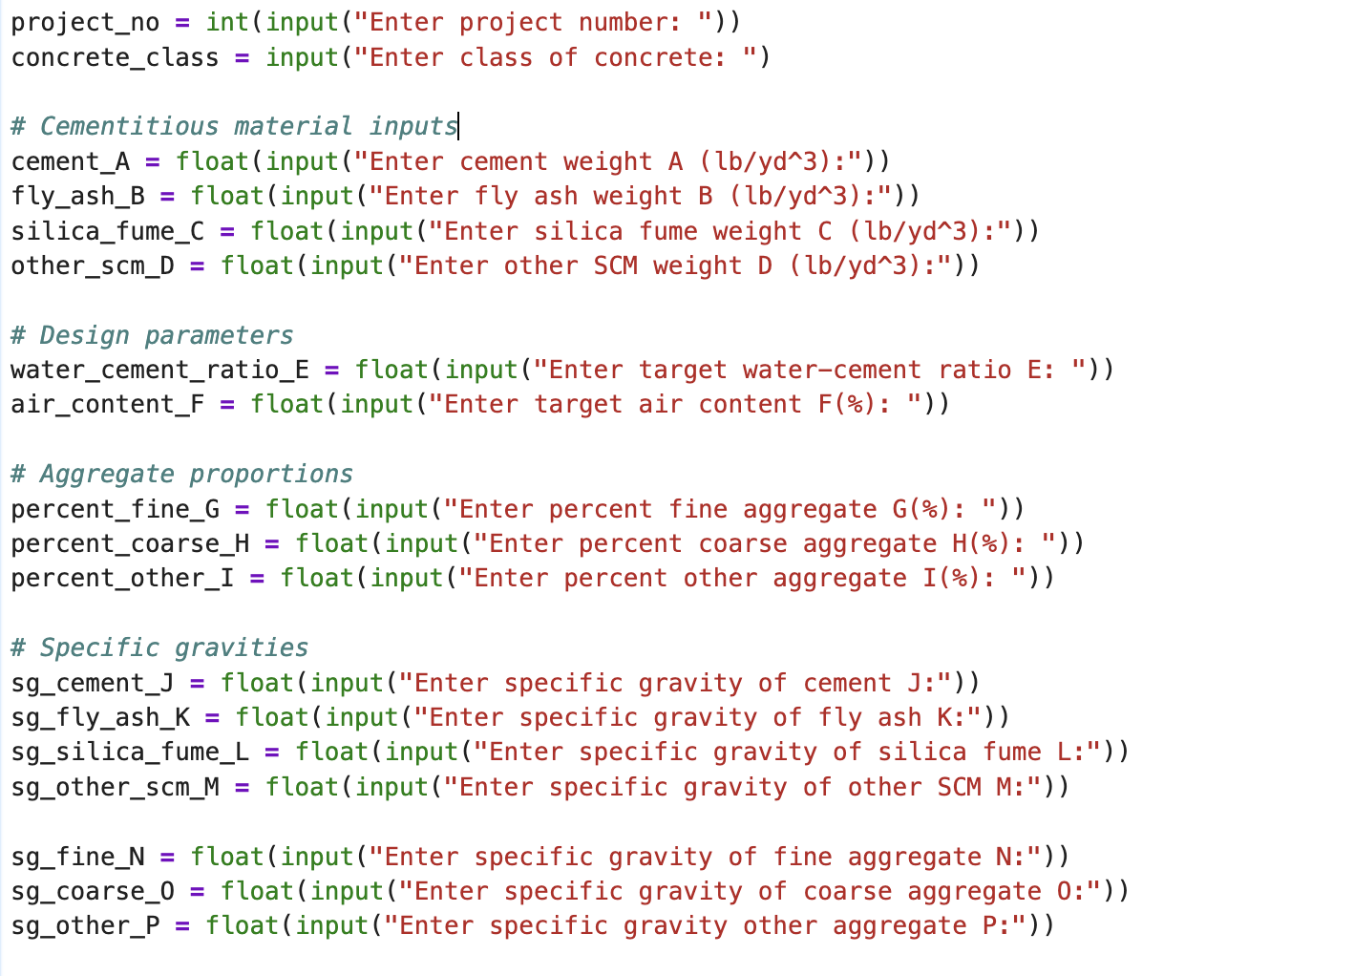 | What this code is doing is getting the variables from the user. It uses the input function so that when this segment of the code is ran it will ask the user for a number and assign it to that variable while also displaying the text in quotations. We put float in front of a majority of the inputs so that the user can input a decimal if needed.
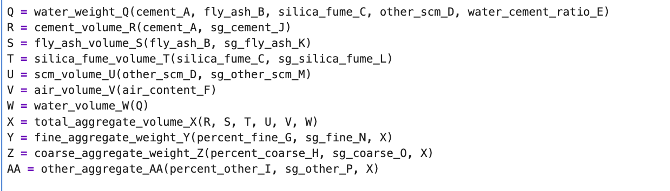 | What this code is doing is calling the functions we defined earlier to do the calculations with the new global variables we just collected from the user. After it passes through the variable into the function it assigns it to its corresponding letter.
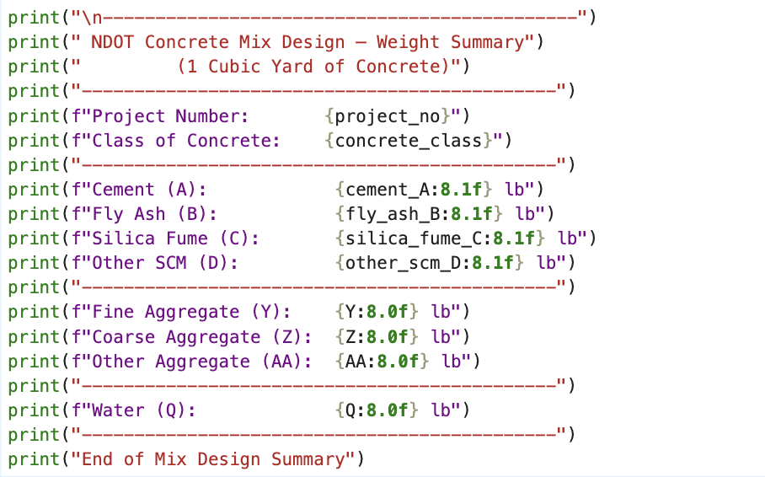 | What this code is doing is just using the print function to sort the data into a professional looking table so that is easily visible. The “8.1f” part in the curly braces is just a way of telling the print statement how many decimals to show.
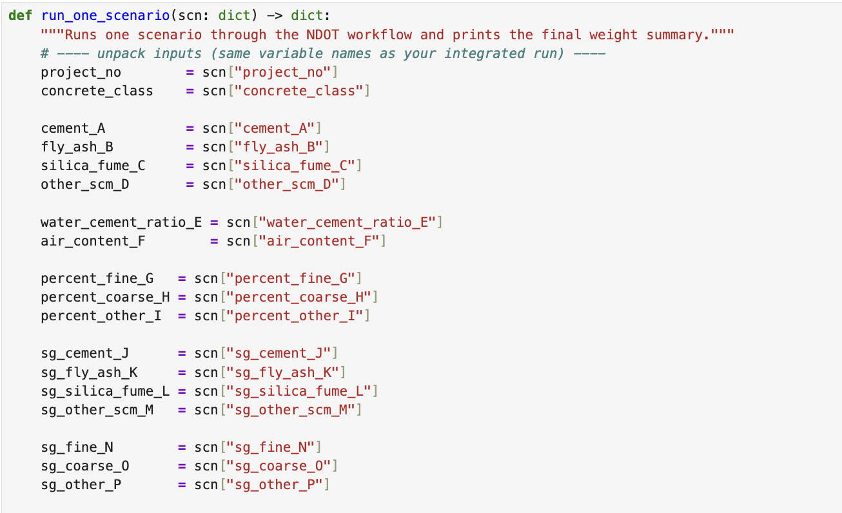 | This code is something we did not cover in class but is something our group researched on our own time which is helpful when wanting to assign multiple different numbers to one variable. Essentially it is doing the same thing as earlier but instead of having the variables be a user input it is assigning them numbers based on the scenario.
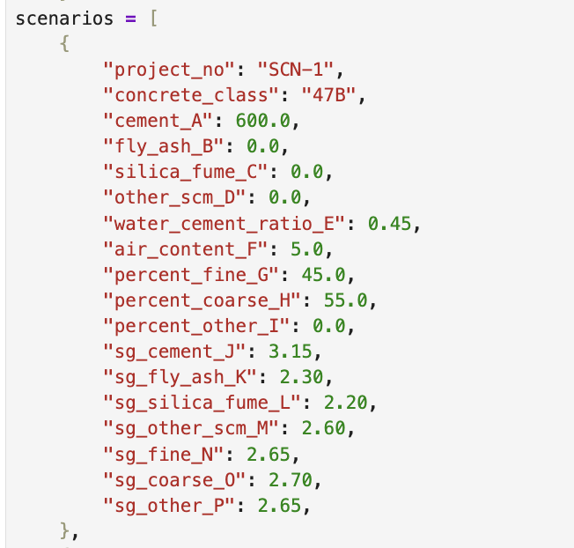 | This is one of the 4 scenarios but they are all doing the same exact thing but just with different numbers. It is giving the named variable we had in the brackets from the code above and giving it a different number.
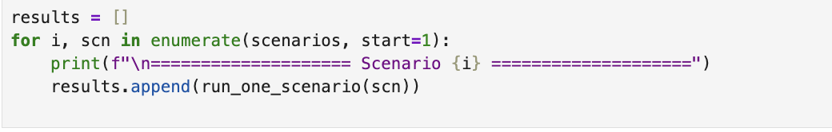 | This code is just displaying the 4 different scenarios by using a for loop so that all 4 of them are shown.

